* **Population** − It is a subset of all the possible (encoded) solutions to the given problem. The population for a GA is analogous to the population for human beings except that instead of human beings, we have Candidate Solutions representing human beings.
* **Chromosomes** − A chromosome is one such solution to the given problem.
* **Gene** − A gene is one element position of a chromosome.
* **Allele** − It is the value a gene takes for a particular chromosome.

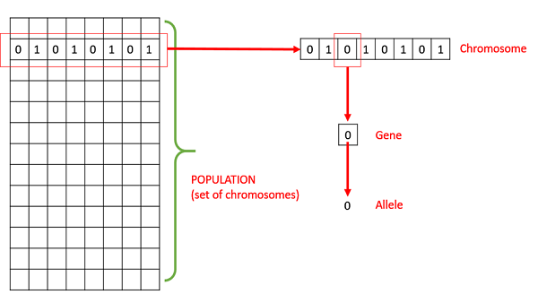

* **Genotype** − Genotype is the population in the computation space. In the computation space, the solutions are represented in a way which can be easily understood and manipulated using a computing system.
* **Phenotype** − Phenotype is the population in the actual real world solution space in which solutions are represented in a way they are represented in real world situations.
* **Decoding and Encoding** − For simple problems, the **phenotype and genotype** spaces are the same. However, in most of the cases, the phenotype and genotype spaces are different. Decoding is a process of transforming a solution from the genotype to the phenotype space, while encoding is a process of transforming from the phenotype to genotype space. Decoding should be fast as it is carried out repeatedly in a GA during the fitness value calculation.